## Problem

The health industry is being revolutionised by technology, it currently has the fastest growth in development of new applications and more of the general public are looking for the latest assistive technology that can work with their healthcare plan. Personal experiences allowed us to analyse certain areas of healthcare, concluding that a significant problem existed with patients that are required to take a high quantity of medication for long-term conditions.

There are many patients that forget to take medication, which accounts for a significant amount of conditions being repeatedly misdiagnosed and prescriptions wrongly assigned to patients [1]. When patients have carers that are responsible for their well-being, this becomes a larger issue.

## Solution

JustHealth anticipated that a bespoke prescription tracking application could be the solution to this issue. After completing research of the competition and target market, we outlined the functionality that would be important to measuring the success of the application. The primary aim of JustHealth was develop a platform that facilitated the relationship between a carer and their patients. The key functions to be implemented were prescription and appointment tracking, with personalised reminders and notifications for each user. This also included a patient management area for the carers and a user management portal for the JustHealth product owners or specified administrators.

## Functionality

Through following an iterative development methodology, we applied some of the tools that are used specifically within Agile [2]. A key feature for outlining the functionality to be implemented is the MoSCoW method, which allowed us to categorise each element of functionality. The four categories are:

* **MUST**: This is essentially the functionality that has to work in order for the project to be considered a success.
* **SHOULD**: This is the functionality that isn’t critical to the operation of the application, but may be required to meet some of the initial project aims.
* **COULD**: Any requirement that is considered a desirable but not necessary functionality, will be implemented if time and other resources permit.
* **WON’T**: Any requirements that we have identified as not critically important and wouldn’t add value to the final product. May be requirements that are unrealistic due to time, cost or resource constraints.

JustHealth used this prioritisation method after separating our initial requirements into different groups of functional, non-functional and domain. Examples of our initial efforts can be found in *Appendix A.*

## Designs

### Branding

There are presently over 31,000 applications on the market that fall into the health & fitness bracket; an industry that is estimated to be worth over $600 million. Although these are unregulated and can be giving misleading information, there is an obvious need to stand out from the market and be unique. JustHealth allocated Ben as the design manager and after a few hours with a sketchpad, discussing aesthetics of logos and designing an image to brand JustHealth with, we had an initial design to build on. We decided it was important to have a logo that included the company name, but containing an image to separate from the main logo for future brand identification.

Whilst researching branding, it was noticeable that there were a number of factors to take into account; these included colours, fonts, size, capitalisation and letter spacing. Some factors are more crucial than others, but essentially branding is important to the success of the product and potentially gaining worldwide recognition.

User feedback regarding the overall image of JustHealth has been positive and we are proud of the brand that we have built thus far.



Caption: Final version of logo design, image has been separated for necessary locations throughout development

### Application

The design process for the JustHealth application was continual throughout development, using our initial ideas to build on but careful consideration of user feedback. The primary reason for designing the way we have is our belief that in order to produce a high quality application, fulfilling the requirements outlined, it’s important to have designs that give an idea of what an appropriate final result might look like.

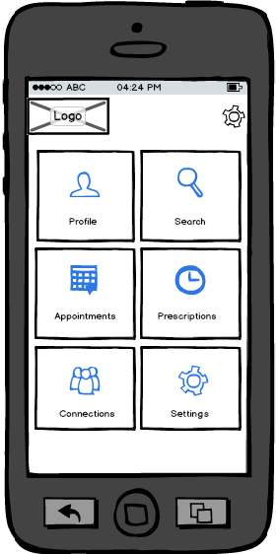Using wire framing design software, Balsamiq (<https://balsamiq.com/>), we were easily able to produce mock-ups to envisage a potential end product. The tool enabled us to adapt the designs for each iteration, and create new mock-ups when required, annotating them to provide extra information when implementing functionality. Producing designs this way saved valuable time and resources that we were able to allocate to other areas of development.

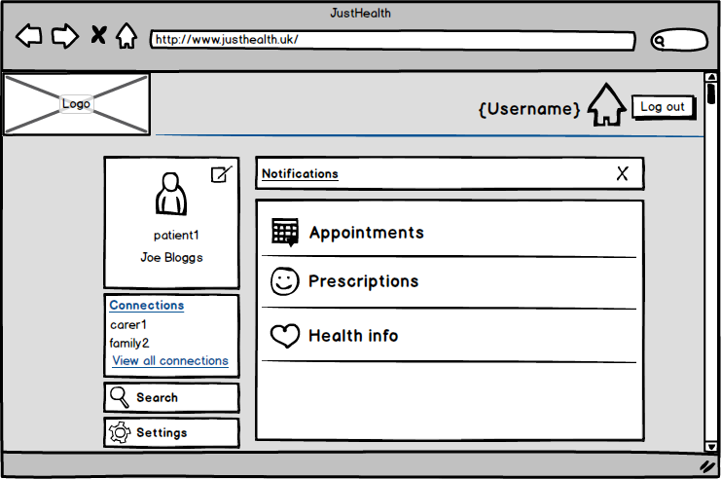

# References

Brown, M. T. & Bussell, J. K., 2011. *Medication Adherence: WHO Cares?.* [Online]   
Available at: http://www.ncbi.nlm.nih.gov/pmc/articles/PMC3068890/  
[Accessed 10 February 2015].

Unknown, n.d. *Agile Methodology.* [Online]   
Available at: http://agilemethodology.org/  
[Accessed 15 February 2015].

(Brown & Bussell, 2011) (Unknown, n.d.)